Civil war in Sierra Leone

UNSC Resolution: | 1370
Date of adoption: | 18 September 2001
Operative paragraph: | 4
Demand number: | 2

Megan MacKenzie

Wording of demand

cease these acts immediately [human rights
abuses and attacks committed by the RUF, the Civil Defence Forces (CDF) and
other armed groups and individuals, against the civilian population]

List of addressees of the demand

Revolutionary United Front, Civil Defence Forces

Short-term compliance

Description of the addressee(s)’ conduct
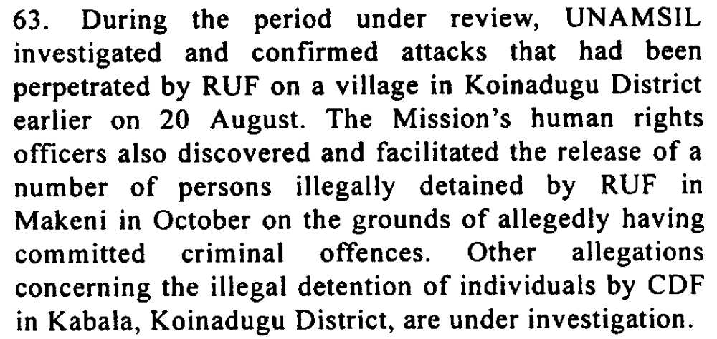

Assessment

Short-term compliance
x No or marginal compliance (1) | Medium low compliance (2) | Medium high compliance (3) | Full or almost full compliance (4)

Considerations underlying the assessment
The resolution is firm in asking the parties to cease human rights violations and abuses against civilians immediately. Both the RUF and CDF clearly did not comply.

Medium-term compliance

Description of the addressee(s)’ conduct
2. During the reporting period, the security situation in Sierra Leone remained
generally stable. There were no major incidents that threatened to cause renewed
instability since the armed attack on the Wellington Barracks armoury in Freetown
by some former soldiers on 13 January 2003. However, these incidents and the
related escape from arrest of former Armed Forces Revolutionary Council/ex-Sierra
Leone Army (AFRC/ex-SLA) leader Johnny Paul Koroma continued to serve as a
reminder of the significant challenges that face Sierra Leone’s security sector.
Unconfirmed reports indicate that Johnny Paul Koroma, who had also been indicted
by the Special Court for Sierra Leone, was recently killed in Liberia, where he
reportedly had been leading an armed group.
3. Another recent challenge is the restiveness on the part of some former
elements of the Civil Defence Force (CDF), the Revolutionary United Front (RUF)
and the AFRC/ex-SLA who are concerned about indictment by the Special Court for
Sierra Leone. In addition, the arrest of former CDF National Coordinator and
Minister of Internal Affairs, Hinga Norman, has provoked resentment among his
supporters, who have attempted to stage violent protests. In this connection, there
are persistent, though unconfirmed, reports that some groups may be plotting violent
actions to disrupt the work of the Special Court.

Assessment

Medium-term compliance
No or marginal compliance (1) | Medium low compliance (2) | x Medium high compliance (3) | Full or almost full compliance (4)

Considerations underlying the assessment
The Security Council reports indicate that all parties were in almost full compliance with this demand. There were isolated incidents of concern but systematic attacks on civilians and human rights abuses clearly decreased within this longer time frame.

Depth of demand

Assessment

Level of depth of demand
Low depth of demand (1) | x Medium depth of demand (2) | High depth of demand (3)

Considerations underlying the assessment

Complying with this demand required that the parties observe human rights laws and restrict their behavior.

Level of confidence about coding decisions

Level of confidence about coding decision
x Extremely high | High | Moderate

Comments to IPI (if any)

Civil war in Sierra Leone

UNSC Resolution: | 1370
Date of adoption: | 18 September 2001
Operative paragraph: | 5
Demand number: | 1

Megan MacKenzie

Wording of demand
continue those efforts [efforts towards full implementation of the Ceasefire Agreement signed in Abuja]

List of addressees of the demand
Government of Sierra Leone, Revolutionary United Front

Short-term compliance

Description of the addressee(s)’ conduct
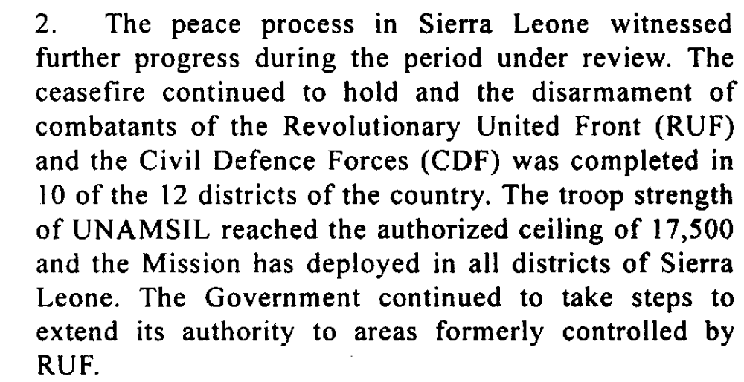
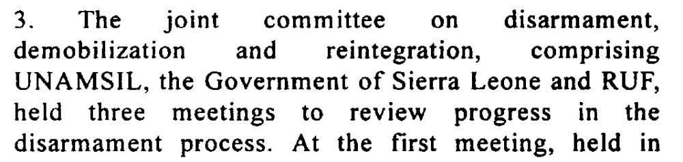
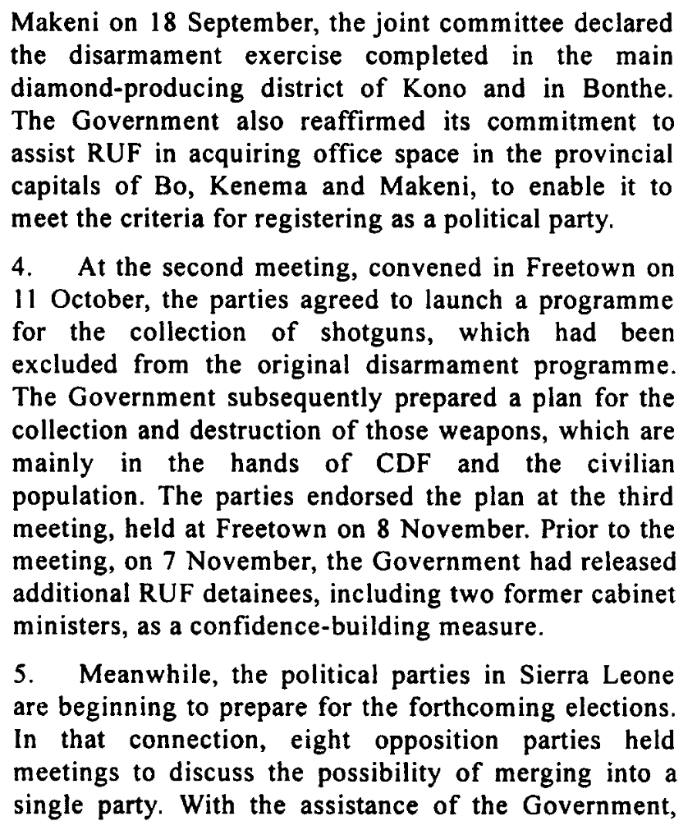
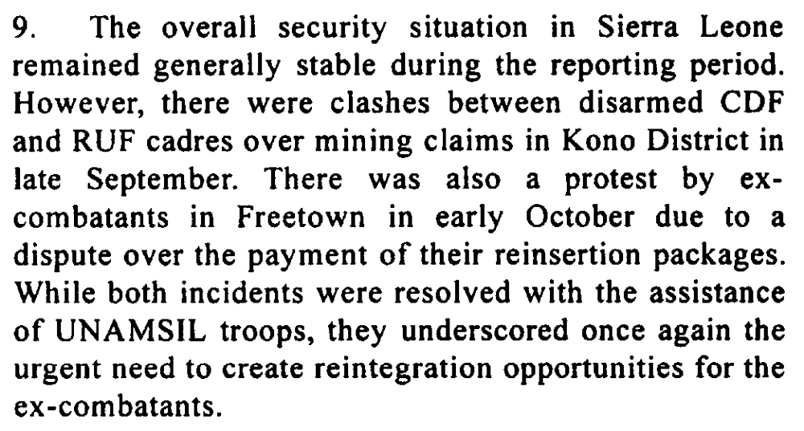

Assessment

Short-term compliance
No or marginal compliance (1) | Medium low compliance (2) | x Medium high compliance (3) | Full or almost full compliance (4)

Considerations underlying the assessment
The demand asks for the parties to continue their efforts with regard to the implementation of the Abuja Ceasefire Agreement. Despite isolated incidents of hostility, the parties clearly made significant effort to implement this agreement and to work towards peace.

Medium-term compliance

Description of the addressee(s)’ conduct
4. It would be recalled that, at the Consultative Group meeting held in Paris in
December 2002 between the Government of Sierra Leone and its development
partners, the Government had undertaken to dismantle the CDF by January 2003. To
date, the CDF continues to exist as an organized group and, in some areas, its
structures operate almost in parallel to those of the Government’s security sector. In
the aftermath of the incident at Wellington Barracks referred to above, and as a
result of lingering doubts about the reliability of the Sierra Leone armed forces,
there have been renewed calls to transform the CDF into a Territorial Defence
Force. The Government has, however, denied that it intends to form such a force.
15. The Republic of Sierra Leone Armed Forces (RSLAF) continued to take steps
to overcome the challenges posed by its restructuring and to provide external
security for the country. The restructuring of the force, which should result in the
reduction of its personnel from the current level of about 14,000 to about 10,500
troops, is ongoing.
18. Since my last report, the availability of reintegration opportunities to former
combatants has improved, with more than 5,500 additional ex-combatants benefiting
from new projects. According to the National Committee for Disarmament,
Demobilization and Reintegration, as of June 2003, there is a remaining caseload of
9,100 ex-combatants who are yet to benefit from reintegration projects. The
Government intends to complete the programme by the end of 2003. However, there
is still a shortfall, estimated at $3 million, in the World Bank-managed Multi-Donor
Trust Fund for disarmament, demobilization and reintegration
41. Significant progress has been made in the efforts to promote human rights,
national reconciliation and justice, and in addressing the needs of children affected
by the conflict, which are key aspects of the overall peace consolidation strategy. In
this connection, the work of the Court and the Truth and Reconciliation Commission
has gathered pace. .

Assessment

Medium-term compliance
No or marginal compliance (1) | Medium low compliance (2) | Medium high compliance (3) | x Full or almost full compliance (4)

Considerations underlying the assessment
Within this longer time frame the war was declared over by the President of Sierra Leone and clear steps had been made by all parties to comply with this demand.

Depth of demand

Assessment

Level of depth of demand
Low depth of demand (1) | x Medium depth of demand (2) | High depth of demand (3)

Considerations underlying the assessment
Although complying with this demand required resources and the significant altering of behavior for the parties, it was in the interests of both parties- particularly the Government of Sierra Leone- to comply with this demand.

Level of confidence about coding decisions

Level of confidence about coding decision
x Extremely high | High | Moderate

Comments to IPI (if any)

Civil war in Sierra Leone

UNSC Resolution: | 1370
Date of adoption: | 18 September 2001
Operative paragraph: | 6
Demand number: | 2

Megan MacKenzie

Wording of demand
Revolutionary United Front

List of addressees of the demand
step up its efforts to fulfill its commitment under the Abuja Ceasefire Agreement to ensure full liberty for the United Nations to deploy its troops throughout the country and also, with a view to restoring the authority of the Government of Sierra Leone throughout the country, to ensure the free movement of persons, goods and humanitarian assistance, unimpeded and safe movement of humanitarian agencies, refugees and displaced persons and the immediate return of all seized weapons, ammunition and other equipment

Short-term compliance

Description of the addressee(s)’ conduct
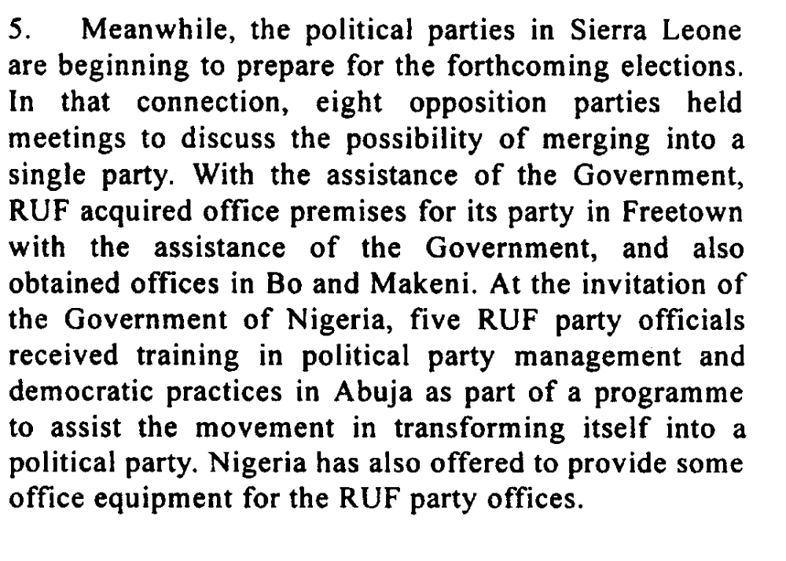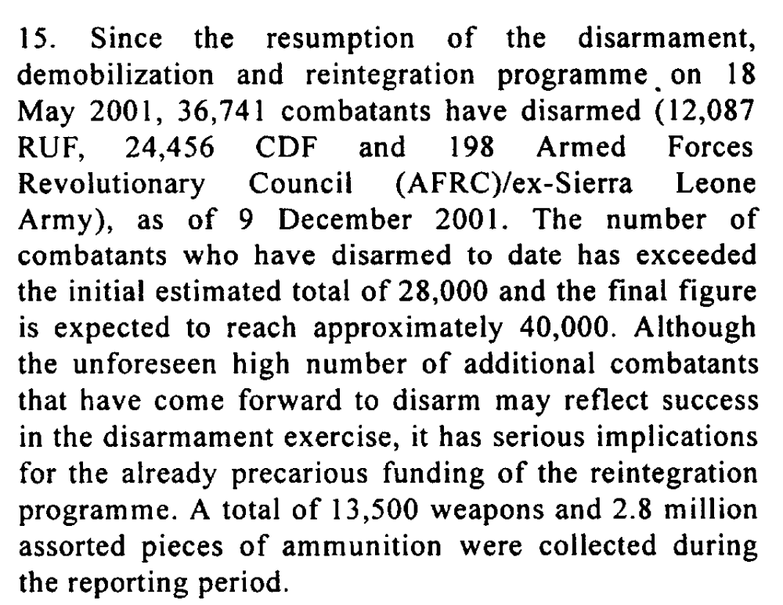
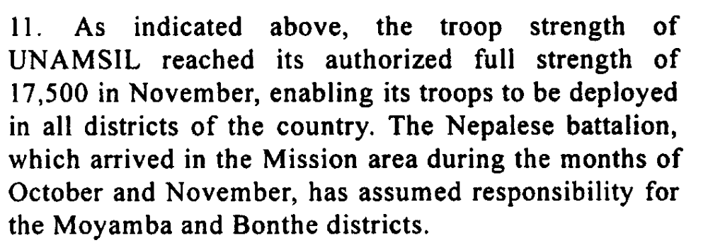

Assessment

Short-term compliance
No or marginal compliance (1) | Medium low compliance (2) | x Medium high compliance (3) | Full or almost full compliance (4)

Considerations underlying the assessment

The RUF did not fully comply with this demand; however they made significant efforts to comply. They worked towards operating as a political party, participated in the disarmament process, and UN and government troops access to previously controlled areas.

Medium-term compliance

Description of the addressee(s)’ conduct
2. During the reporting period, the security situation in Sierra Leone remained
generally stable. There were no major incidents that threatened to cause renewed
instability since the armed attack on the Wellington Barracks armoury in Freetown
by some former soldiers on 13 January 2003. However, these incidents and the
related escape from arrest of former Armed Forces Revolutionary Council/ex-Sierra
Leone Army (AFRC/ex-SLA) leader Johnny Paul Koroma continued to serve as a
reminder of the significant challenges that face Sierra Leone’s security sector.
Unconfirmed reports indicate that Johnny Paul Koroma, who had also been indicted
by the Special Court for Sierra Leone, was recently killed in Liberia, where he
reportedly had been leading an armed group.
3. Another recent challenge is the restiveness on the part of some former
elements of the Civil Defence Force (CDF), the Revolutionary United Front (RUF)
and the AFRC/ex-SLA who are concerned about indictment by the Special Court for
Sierra Leone.
6. These challenges notwithstanding, the overall security threat from internal
factors in Sierra Leone is assessed as relatively low in the short term, particularly
due to the gradual manner in which UNAMSIL continues to conduct its drawdown
and the concerted efforts of the Mission and Sierra Leone’s security agencies in
rigorously monitoring the security situation. In this context, UNAMSIL continues to
maintain an appropriate level of capability to deter possible renewed instability and
has provided support for the deployments and operations of the national army and
police throughout the country.
18. Since my last report, the availability of reintegration opportunities to former
combatants has improved, with more than 5,500 additional ex-combatants benefiting
from new projects. According to the National Committee for Disarmament,
Demobilization and Reintegration, as of June 2003, there is a remaining caseload of
9,100 ex-combatants who are yet to benefit from reintegration projects. The
Government intends to complete the programme by the end of 2003. However, there
is still a shortfall, estimated at $3 million, in the World Bank-managed Multi-Donor
Trust Fund for disarmament, demobilization and reintegration.

Assessment

Medium-term compliance
No or marginal compliance (1) | Medium low compliance (2) | Medium high compliance (3) | x Full or almost full compliance (4)

Considerations underlying the assessment

Within this longer time frame the RUF almost disappeared as a significant force and security threat within Sierra Leone. They participated in the DDR and worked with the GoSL to hold elections.

Depth of demand

Assessment

Level of depth of demand
Low depth of demand (1) | Medium depth of demand (2) | x High depth of demand (3)

Considerations underlying the assessment

This was a complex and detailed demand, which required the RUF to monitor and change their behavior. In particular, complying with this demand meant that the RUF relinquished a significant amount of their power and authority in the country.

Level of confidence about coding decisions

Level of confidence about coding decision
Extremely high | x High | Moderate

Comments to IPI (if any)

Civil war in Sierra Leone

UNSC Resolution: | 1370
Date of adoption: | 18 September 2001
Operative paragraph: | 7
Demand number: | 1

Megan MacKenzie

Wording of demand
continue to take steps towards furthering of dialogue and national reconciliation

List of addressees of the demand
Government of Sierra Leone, Revolutionary United Front

Short-term compliance

Description of the addressee(s)’ conduct
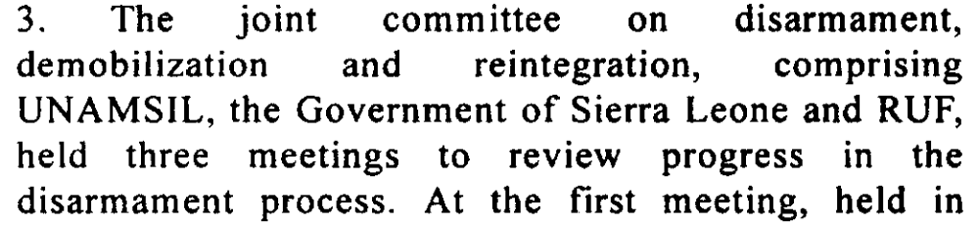
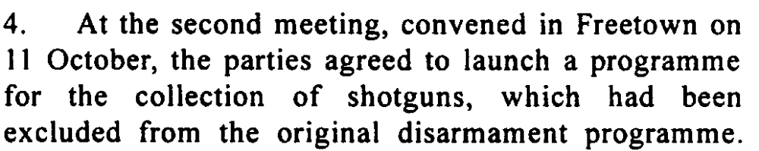
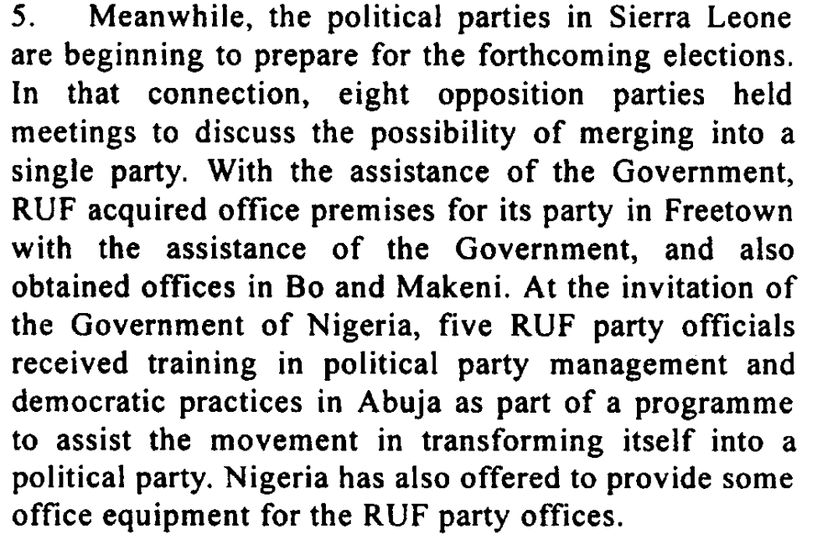

Assessment

Short-term compliance
No or marginal compliance (1) | Medium low compliance (2) | Medium high compliance (3) | x Full or almost full compliance (4)

Considerations underlying the assessment

The progress with the DDR and the implementation of the Peace Agreement is a testament of the parties’ willingness to participate in dialogue with one another.

Medium-term compliance

Description of the addressee(s)’ conduct
2. During the reporting period, the security situation in Sierra Leone remained
generally stable. There were no major incidents that threatened to cause renewed
instability since the armed attack on the Wellington Barracks armoury in Freetown
by some former soldiers on 13 January 2003. However, these incidents and the
related escape from arrest of former Armed Forces Revolutionary Council/ex-Sierra
Leone Army (AFRC/ex-SLA) leader Johnny Paul Koroma continued to serve as a
reminder of the significant challenges that face Sierra Leone’s security sector.
Unconfirmed reports indicate that Johnny Paul Koroma, who had also been indicted
by the Special Court for Sierra Leone, was recently killed in Liberia, where he
reportedly had been leading an armed group.
3. Another recent challenge is the restiveness on the part of some former
elements of the Civil Defence Force (CDF), the Revolutionary United Front (RUF)
and the AFRC/ex-SLA who are concerned about indictment by the Special Court for
Sierra Leone.

Assessment

Medium-term compliance
No or marginal compliance (1) | Medium low compliance (2) | Medium high compliance (3) | x Full or almost full compliance (4)

Considerations underlying the assessment

Within this longer time frame the war was declared over. This is largely attributed to the dialogue and cooperation between the parties.

Depth of demand

Assessment

Level of depth of demand
Low depth of demand (1) | x Medium depth of demand (2) | High depth of demand (3)

Considerations underlying the assessment
Participating in dialogue did not require a significant change in behaviors.

Level of confidence about coding decisions

Level of confidence about coding decision
Extremely high | x High | Moderate

Comments to IPI (if any)

At this stage, it is difficult to assess the depth of the demands. Peace was beginning to be established at this time so in some ways the demands are not requiring parties to alter their behavior significantly.

Civil war in Sierra Leone

UNSC Resolution: | 1370
Date of adoption: | 18 September 2001
Operative paragraph: | 7
Demand number: | 1

Megan MacKenzie

Wording of demand

cease any effort at maintaining options for military action

List of addressees of the demand

Revolutionary United Front

Short-term compliance

Description of the addressee(s)’ conduct
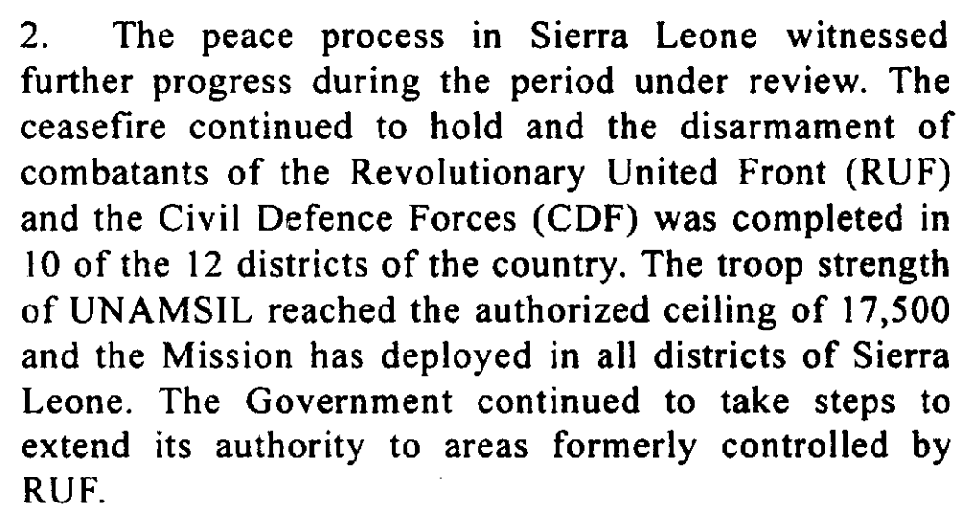
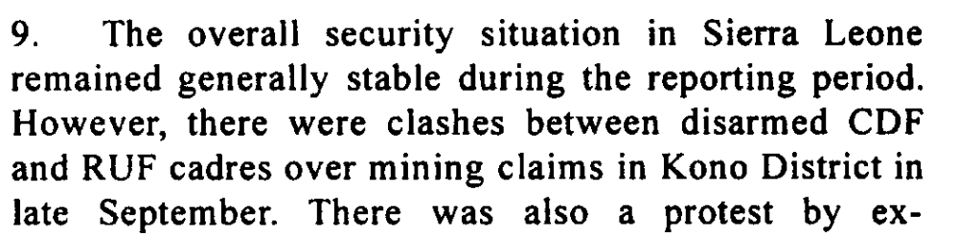
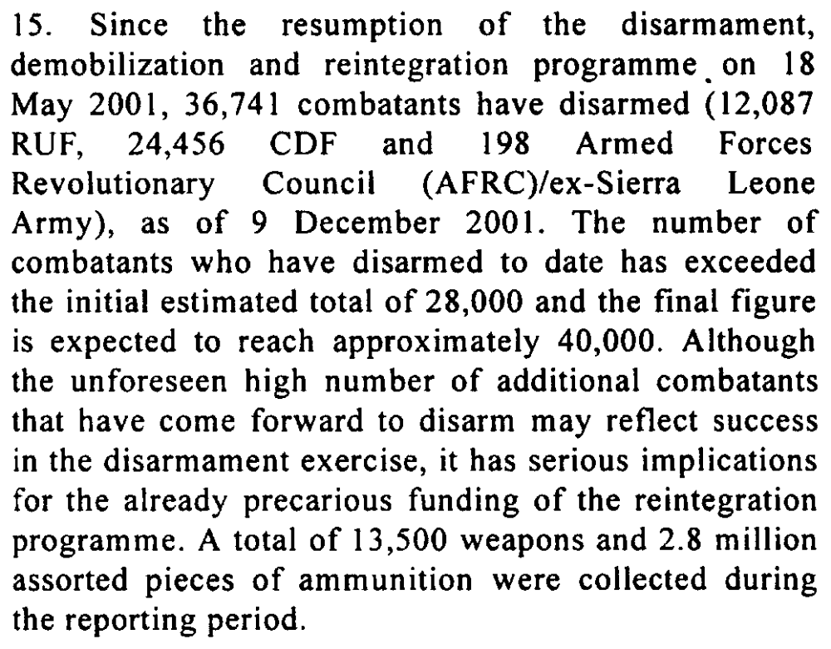

Assessment

Short-term compliance
No or marginal compliance (1) | Medium low compliance (2) | Medium high compliance (3) | x Full or almost full compliance (4)

Considerations underlying the assessment
There were no major armed incidents during this period and the RUF were participating in the disarmament program.

Medium-term compliance

Description of the addressee(s)’ conduct

Since the May 2002 elections the former rebel
group turned political party, the Revolutionary
United Front Party (RUF-P), has suffered more
divisions and lost much of what little support it had
prior to entering the political contest.126 It has poor
prospects for survival, particularly after the
indictment of four of its top leaders by the Special
Court.127 As a fighting force, the RUF is obsolete.

NEW YORK, 18 January (UN Headquarters) -- The following statement was issued today by the Spokesman for Secretary-General Kofi Annan:
The Secretary-General welcomes the formal completion of the disarmament process in Sierra Leone on 11 January 2002. A symbolic bonfire of weapons and ammunition, marking the completion of the process, took place today in Lungi, Sierra Leone, witnessed by several heads of State and government representatives from the West African subregion.
The Secretary-General notes that the forthcoming parliamentary and presidential elections in May 2002, the extension of State authority throughout the country, the restoration of ex-combatants, the restoration of the Government’s control over natural resources, and the resettlement of returning refugees and internally displaced persons, as well as forging national reconciliation, remain crucial tasks for the peace process which also requires generous support from the international community.

Assessment

Medium-term compliance
No or marginal compliance (1) | Medium low compliance (2) | Medium high compliance (3) | x Full or almost full compliance (4)

Considerations underlying the assessment
The RUF was no longer a significant fighting force and had participated in higher numbers than expected in the disarmament process.

Depth of demand

Assessment

Level of depth of demand
Low depth of demand (1) | x Medium depth of demand (2) | High depth of demand (3)

Considerations underlying the assessment
At this time, this demand was not a high depth demand. The RUF had already agreed to participate in the peace process and transform from a military organization to a political one.

Level of confidence about coding decisions

Level of confidence about coding decision
Extremely high | x High | Moderate

Comments to IPI (if any)

Civil war in Sierra Leone

UNSC Resolution: | 1370
Date of adoption: | 18 September 2001
Operative paragraph: | 8
Demand number: | 1

Megan MacKenzie

Wording of demand

cooperate to this end in fulfillment of its commitments under the Abuja Ceasefire Agreement

List of addressees of the demand

Revolutionary United Front

Short-term compliance

Description of the addressee(s)’ conduct

Since the signing of Abuja II, over 22,000 RUF
and CDF combatants have entered the
Disarmament, Demobilisation, Reintegration
(DDR) process, almost one half of the estimated
total of 45,000 combatants in the country. The
cease-fire has also held since May, though with
the notable exception of RUF-CDF skirmishes in
the diamond-producing Kono district in the east.

Assessment

Short-term compliance
No or marginal compliance (1) | Medium low compliance (2) | Medium high compliance (3) | x Full or almost full compliance (4)

Considerations underlying the assessment

There are strong indications that the RUF cooperated and fulfilled its commitments to the Abuja Ceasefire Agreement- particularly with regard to disarmament and the ceasefire agreement.

Medium-term compliance

Description of the addressee(s)’ conduct

2. During the reporting period, the security situation in Sierra Leone remained
generally stable. There were no major incidents that threatened to cause renewed
instability since the armed attack on the Wellington Barracks armoury in Freetown
by some former soldiers on 13 January 2003. However, these incidents and the
related escape from arrest of former Armed Forces Revolutionary Council/ex-Sierra
Leone Army (AFRC/ex-SLA) leader Johnny Paul Koroma continued to serve as a
reminder of the significant challenges that face Sierra Leone’s security sector.
Unconfirmed reports indicate that Johnny Paul Koroma, who had also been indicted
by the Special Court for Sierra Leone, was recently killed in Liberia, where he
reportedly had been leading an armed group.
3. Another recent challenge is the restiveness on the part of some former
elements of the Civil Defence Force (CDF), the Revolutionary United Front (RUF)
and the AFRC/ex-SLA who are concerned about indictment by the Special Court for
Sierra Leone.

Assessment

Medium-term compliance
No or marginal compliance (1) | Medium low compliance (2) | Medium high compliance (3) | x Full or almost full compliance (4)

Considerations underlying the assessment

Despite isolated incidents of insecurity or frustration on the part of the RUF, in general they fulfilled their commitment to the Peace Agreement.

Depth of demand

Assessment

Level of depth of demand
Low depth of demand (1) | x Medium depth of demand (2) | High depth of demand (3)

Considerations underlying the assessment

At this time, this demand was not a high depth demand. The RUF had diminished as a military group and had already agreed to participate in the peace process and transform from a military organization to a political one.

Level of confidence about coding decisions

Level of confidence about coding decision
Extremely high | x High | Moderate

Comments to IPI (if any)

Civil war in Sierra Leone

UNSC Resolution: | 1370
Date of adoption: | 18 September 2001
Operative paragraph: | 13
Demand number: | 1

Megan MacKenzie

Wording of demand
continue their commitment to, and active participation in, the programme [disarmament, demobilization and reintegration]

List of addressees of the demand

Government of Sierra Leone, Sierra Leone Army, Civil Defence Forces , Revolutionary United Front

Short-term compliance

RUF’s response in Kambia was overwhelming, and the quality of weapons turned over at the reception center was high. Turnout at the Port Loko site was quite low….By the end of Oct 2001, the pace of the program had increased to meet its goal of completion before the May 2002 elections.

CDF, inspite of having participated in disarmament, reportedly had, in 2002, maintained a number of its battalions (an estimated 10,200 fighters).

Notes- not about participation but about quality of program
Disarmament smoth demobilization beset with challenges. …the gov did not reliably process and distribute reinsertion packages and transition allowances, so ex-combatants lintered with their unites near disarmament ceters instead of returning to their home communities. …violence broke out sporatically at several demobilization reception centers.

Description of the addressee(s)’ conduct

Assessment

Short-term compliance
No or marginal compliance (1) | Medium low compliance (2) | Medium high compliance (3) | x Full or almost full compliance (4)

Considerations underlying the assessment
There is indication that most of the parties were participating in the DDR in high numbers; however, concerns remained about the CDF. The CDF resisted participation and maintained their organization and structure in some areas after this demand was issued.

Medium-term compliance

Description of the addressee(s)’ conduct
NEW YORK, 18 January (UN Headquarters) -- The following statement was issued today by the Spokesman for Secretary-General Kofi Annan:
The Secretary-General welcomes the formal completion of the disarmament process in Sierra Leone on 11 January 2002. A symbolic bonfire of weapons and ammunition, marking the completion of the process, took place today in Lungi, Sierra Leone, witnessed by several heads of State and government representatives from the West African subregion.
The Secretary-General notes that the forthcoming parliamentary and presidential elections in May 2002, the extension of State authority throughout the country, the restoration of ex-combatants, the restoration of the Government’s control over natural resources, and the resettlement of returning refugees and internally displaced persons, as well as forging national reconciliation, remain crucial tasks for the peace process which also requires generous support from the international community.

Assessment

Medium-term compliance
No or marginal compliance (1) | Medium low compliance (2) | Medium high compliance (3) | x Full or almost full compliance (4)

Considerations underlying the assessment

There were many concerns about the quality of the DDR process and with the participation of the CDF; however, the process was declared over and an overall success within this time frame.

Depth of demand

Assessment

Level of depth of demand
Low depth of demand (1) | x Medium depth of demand (2) | High depth of demand (3)

Considerations underlying the assessment
The process was well under way and it was in the interests of the parties to participate at this point rather than resist.

Level of confidence about coding decisions

Level of confidence about coding decision
Extremely high | High | x Moderate

Comments to IPI (if any)

Civil war in Sierra Leone

UNSC Resolution: | 1370
Date of adoption: | 18 September 2001
Operative paragraph: | 16
Demand number: | 2

Megan MacKenzie

Wording of demand
accelerate and coordinate efforts to restore civil authority and basic public services throughout the country (including in the diamond mining areas), including by the deployment of key administrative officials and the Sierra Leone police and the progressive involvement of the Sierra Leone Army in providing border security against external forces

List of addressees of the demand

Government of Sierra Leone

Short-term compliance

Description of the addressee(s)’ conduct
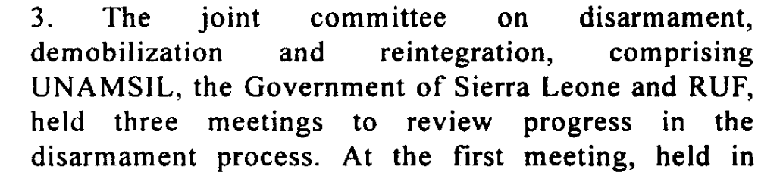
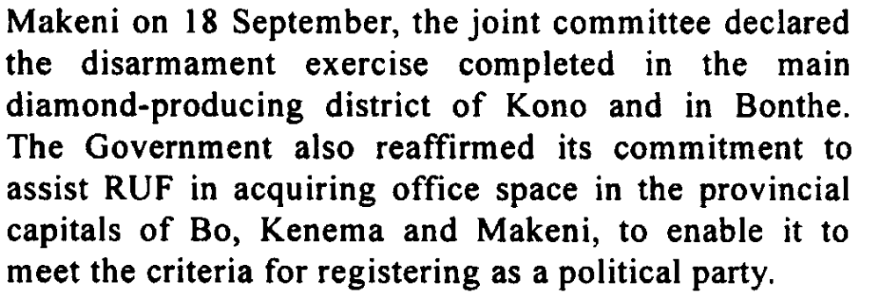

Assessment

Short-term compliance
No or marginal compliance (1) | Medium low compliance (2) | x Medium high compliance (3) | Full or almost full compliance (4)

Considerations underlying the assessment
This demand specifically mentions the diamond producing region and it is clear that major strides had been made in the short term with the disarmament complete in this region. In addition, it is clear that civilian authority was becoming well established.

Medium-term compliance

Description of the addressee(s)’ conduct
While UNASMIL has been pulling out as planned,
concerns have grown that the government will not
meet the benchmarks, especially on police and
diamond mining.

As of July 2003, the police in particular were
finding it difficult to meet the benchmarks of the
withdrawal process. They are under-equipped,
under-staffed, and under-trained, and their
deployment in many parts of the country is in such
small numbers as to be more ceremonial than
practical.
The military (RSLAF) is faring better [than the police],
even though it is also short on equipment, housing
and training. Its performance in response to border
incursions occasioned by the Liberian civil war has
been erratic and at times unreliable.

Assessment

Medium-term compliance
No or marginal compliance (1) | x Medium low compliance (2) | Medium high compliance (3) | Full or almost full compliance (4)

Considerations underlying the assessment
Although there were positive indications that this demand would be met in the short term, there remain serious concerns about the legitimacy and strength of the Sierra Leone Police force, border issues with Liberia, and security in the diamond producing regions.

Depth of demand

Assessment

Level of depth of demand
Low depth of demand (1) | x Medium depth of demand (2) | High depth of demand (3)

Considerations underlying the assessment
This demand was complex and included several sub-demands; however, the demands were primarily in the interests of the Government of Sierra Leone.

Level of confidence about coding decisions

Level of confidence about coding decision
Extremely high | x High | Moderate

Comments to IPI (if any)

Civil war in Sierra Leone

UNSC Resolution: | 1370
Date of adoption: | 18 September 2001
Operative paragraph: | 17
Demand number: | 2

Megan MacKenzie

Wording of demand
expedite the establishment of the Truth and Reconciliation Commission and the Special Court envisaged by resolution 1315 (2000) of 14 August 2000, bearing in mind in particular the need to ensure the appropriate protection of children

List of addressees of the demand

Government of Sierra Leone

Short-term compliance

Description of the addressee(s)’ conduct

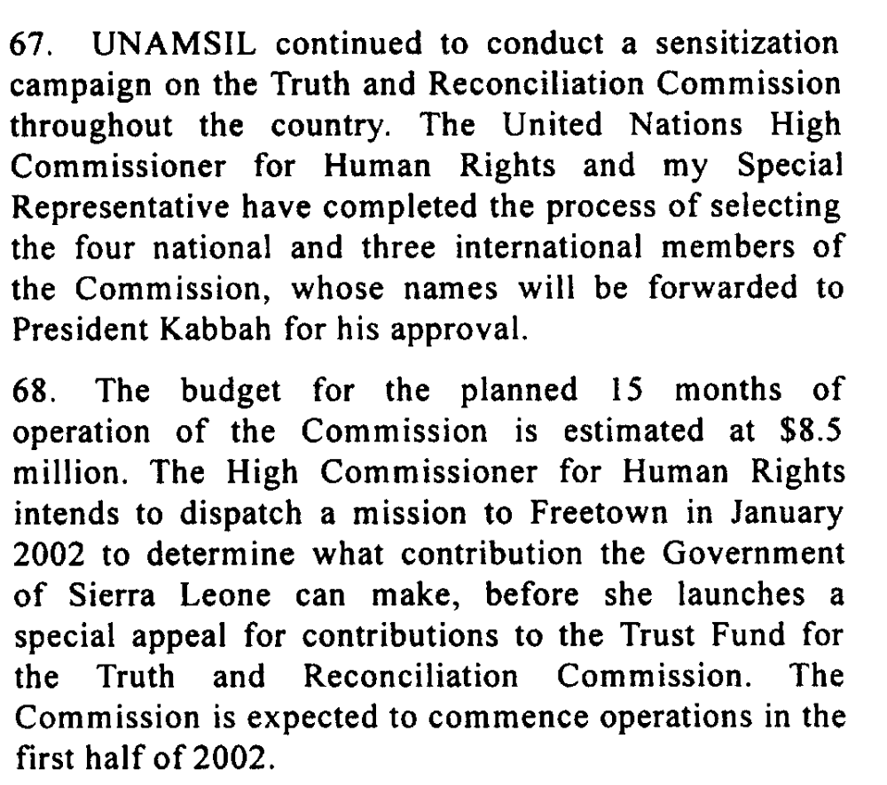

Assessment

Short-term compliance
No or marginal compliance (1) | Medium low compliance (2) | x Medium high compliance (3) | Full or almost full compliance (4)

Considerations underlying the assessment

During this period major steps were made by the Government to establish the Truth and Reconciliation Commission. However, the demand uses the word expedite and during this period the TRC was still very much in the early planning phases.

Medium-term compliance

Description of the addressee(s)’ conduct

After a troubled start at the end of 2002, the TRC
appears to be on a solid footing.92 Statement-takers
have collected many statements from both victims
and perpetrators. A new executive secretary,
Franklyn Kargbo, and much of the permanent
secretariat staff were on board by the end of February
2003.Public hearings began in Freetown on 14
April, continued throughout the country and
concluded on 5 August. A TRC representative
expressed confidence that given adequate funds the
Commissioners will meet the original deadline of
October 2003 for submitting a final report.

The TRC’s work has two phases: a three-month
preparatory period followed by a twelve-month
operational one. The preparatory phase began on 5
July 2002 and, although a number of tasks were not
completed, concluded on 4 October.

President Kabbah’s government has pledged its
moral commitment to the TRC process and, more
concretely, has provided U.S.$97,000 in seed
money, donated a building for the Secretariat, and
made available other facilities in government
ministries.
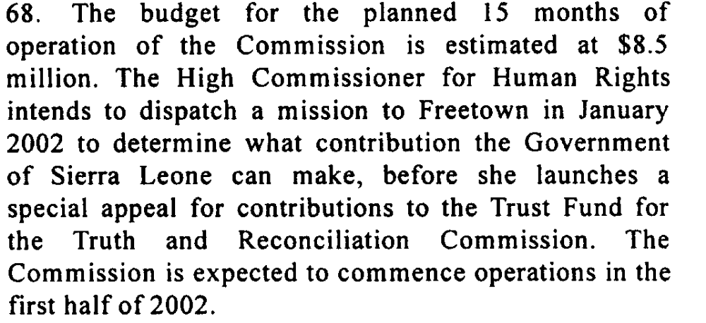

Assessment

Medium-term compliance
No or marginal compliance (1) | Medium low compliance (2) | x Medium high compliance (3) | Full or almost full compliance (4)

Considerations underlying the assessment

Obvious steps were made to establish the TRC but the demand specifically uses the word ‘expedite’ and there is evidence that the process experienced several delays and took a long time to get established.

Depth of demand

Assessment

Level of depth of demand
x Low depth of demand (1) | Medium depth of demand (2) | High depth of demand (3)

Considerations underlying the assessment
Establishing the TRC was very much in the interests of the Government of Sierra Leone. It required expertise and resources but it also served to facilitate peacebuilding and the legitimacy of the government.

Level of confidence about coding decisions

Level of confidence about coding decision
x Extremely high | High | Moderate

Comments to IPI (if any)

Civil war in Sierra Leone

UNSC Resolution: | 1389
Date of adoption: | 16 January 2002
Operative paragraph: | 7
Demand number: | 1

Megan MacKenzie

Wording of demand

holding of free and fair elections

List of addressees of the demand

Government of Sierra Leone

Short-term compliance

Description of the addressee(s)’ conduct
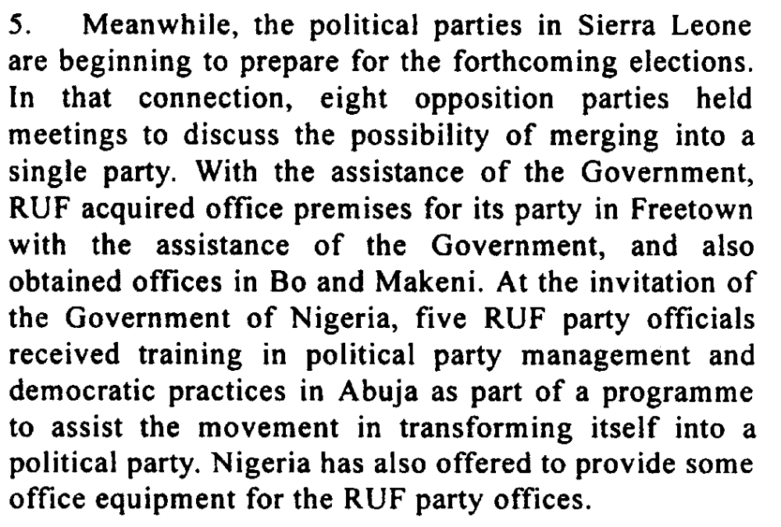

Assessment

Short-term compliance
No or marginal compliance (1) | x Medium low compliance (2) | Medium high compliance (3) | Full or almost full compliance (4)

Considerations underlying the assessment

The elections were not held within this time frame but clear efforts were made to work towards holding the elections.

Medium-term compliance

Description of the addressee(s)’ conduct
The elections were
initially scheduled for April 2003 but have already
been postponed once and may be again until local
government legislation is passed and the debate about
the type of elections is settled. It is hoped that
elections will be possible in the first half of 2004.

The hard won peace culminated in
presidential and parliamentary elections on 10 and
14 May 20021 that were largely without violent
incidents but were marred by serious irregularities.

Assessment

Medium-term compliance
No or marginal compliance (1) | Medium low compliance (2) | Medium high compliance (3) | x Full or almost full compliance (4)

Considerations underlying the assessment

Elections were held within this time frame. There were some delays but the demand does not give a specific time frame.

Depth of demand

Assessment

Level of depth of demand
Low depth of demand (1) | x Medium depth of demand (2) | High depth of demand (3)

Considerations underlying the assessment

It was in the interests of the party to hold free and fair elections; however, it required significant mobilization, resources, and coordination. Holding free and fair elections after such a long period of insecurity was a major task.

Level of confidence about coding decisions

Level of confidence about coding decision
Extremely high | x High | Moderate

Comments to IPI (if any)

United Nations Secretary General Twelfth report of the Secretary-General on UNAMSIL13 December 2001
United Nations Secretary General Eighteenth report of the Secretary-General on UNAMSIL 23 June 2003
United Nations Secretary General Twelfth report of the Secretary-General on UNAMSIL13 December 2001
United Nations Secretary General Eighteenth report of the Secretary-General on UNAMSIL 23 June 2003
United Nations Secretary General Twelfth report of the Secretary-General on UNAMSIL13 December 2001
United Nations Secretary General Eighteenth report of the Secretary-General on UNAMSIL 23 June 2003
United Nations Secretary General Twelfth report of the Secretary-General on UNAMSIL13 December 2001
United Nations Secretary General Eighteenth report of the Secretary-General on UNAMSIL 23 June 2003
United Nations Secretary General Twelfth report of the Secretary-General on UNAMSIL13 December 2001
International Crisis Group. Sierra Leone: The State of Security and Governance. ICG Africa Report No 67. Freetown/London/Brussels. 3 September 2003. P5.
United Nations Secretary General. “Secretary General Welcomes Completion of Sierra Leone Disarmament Process, Stresses Crucial Tasks Remaining: Statement issued by spokesman for Secretary-General Kofi Annan. http://www.unis.unvienna.org/unis/pressrels/2002/sgsm8103.html 12 January 2002
International Crisis Group. Sierra Leone: Managing Uncertainty. ICG Africa Report No 35. Freetown/London/Brussels. 24 October 2001. P1.
United Nations Secretary General Twelfth report of the Secretary-General on UNAMSIL13 December 2001
Eric G. Berman and Melissa T. Labonte, “Sierra Leone” in William J. Durch ed. Sierra Leone 21st Century Peace Operations. (Washington: United States Institute of Peace) p187
Eric G. Berman and Melissa T. Labonte, “Sierra Leone” in William J. Durch ed. Sierra Leone 21st Century Peace Operations. (Washington: United States Institute of Peace) p188
Eric G. Berman and Melissa T. Labonte, “Sierra Leone” in William J. Durch ed. Sierra Leone 21st Century Peace Operations. (Washington: United States Institute of Peace) p187
United Nations Secretary General. “Secretary General Welcomes Completion of Sierra Leone Disarmament Process, Stresses Crucial Tasks Remaining: Statement issued by spokesman for Secretary-General Kofi Annan. http://www.unis.unvienna.org/unis/pressrels/2002/sgsm8103.html 12 January 2002
United Nations Secretary General Twelfth report of the Secretary-General on UNAMSIL13 December 2001
International Crisis Group. Sierra Leone: The State of Security and Governance. ICG Africa Report No 67. Freetown/London/Brussels. 3 September 2003. P5.
International Crisis Group. Sierra Leone: The State of Security and Governance. ICG Africa Report No 67. Freetown/London/Brussels. 3 September 2003. P5.
United Nations Secretary General Twelfth report of the Secretary-General on UNAMSIL13 December 2001
International Crisis Group. Sierra Leone: The State of Security and Governance. ICG Africa Report No 67. Freetown/London/Brussels. 3 September 2003. P11.
International Crisis Group. Sierra Leone’s Truth and Reconciliation Commission: A Fresh Start. ICG Africa Briefing. Freetown/London/Brussels. 20 December 2002. P2.
International Crisis Group. Sierra Leone’s Truth and Reconciliation Commission: A Fresh Start. ICG Africa Briefing. Freetown/London/Brussels. 20 December 2002. P9.
United Nations Secretary General Twelfth report of the Secretary-General on UNAMSIL13 December 2001
United Nations Secretary General Twelfth report of the Secretary-General on UNAMSIL13 December 2001
International Crisis Group. Sierra Leone: The State of Security and Governance. ICG Africa Report No 67. Freetown/London/Brussels. 3 September 2003. P18.
International Crisis Group. Sierra Leone After Elections: Politics as Usual? ICG Africa Report No 49. Freetown/London/Brussels. 12 July 2002. P1.

